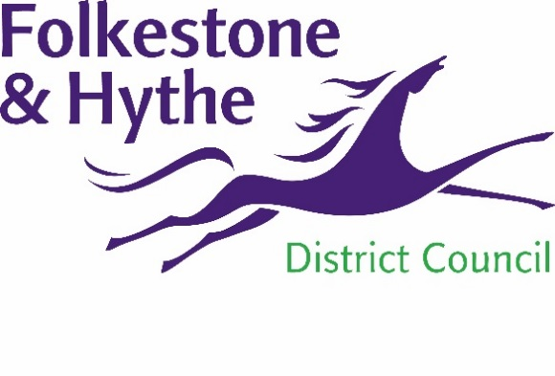
NEWS RELEASE

13 April 2021
SHIP STREET SITE TO BE REVITALISED THANKS TO COUNCIL INTERVENTION

The former gas works site at Ship Street has been purchased by Folkestone & Hythe District Council as part of the strategic regeneration of Folkestone and the wider district.
The large plot commands an important position at the edge of Folkestone Town Centre between Folkestone Central station and the town centre – including the harbour area. However, the former gas works site has long been an eyesore as it was left derelict after it ceased to operate as a gasworks in 1956. Demolition of the structures took place in phases from 1960 with the final structure removed in 2001.
For years there has been no private sector interest in developing the land and so the council – recognising the strategic importance of the location and size of the site – proactively intervened to buy the 1.5 hectare plot from previous owners National Grid.
The plan for the site includes more than 100 new mixed tenure homes, including affordable properties to help meet the needs of local people.
There is also scope for small-scale commercial space and high-quality public areas. Working in partnership with Creative Folkestone the scheme will be developed with an input from the creative sector with a strong focus on design, sustainability and art in public spaces.

Part-remediation of the site was carried out in 2009 but has since sat as redundant brownfield land. Due to challenging topography and contamination, the site needs public support to be transformed and the council has stepped in with the intention of attracting additional investment to deliver the project.
A spokesperson for Folkestone & Hythe District Council said: “This bold purchase has been a long time in the making and we are delighted that we will bring this brownfield site back into use for the wider benefit of Folkestone.
“The attractive walking experience that will be created between key points in the town as part of this scheme will improve the experience of residents and visitors as well as contributing the wider regeneration of the area.
“We are excited to transform this unsightly plot into a truly exemplar development. This scheme will add to the distinctive cultural character of Folkestone and promotes a high quality sense of place whilst providing well designed and sustainable housing.”
Alastair Upton, Chief Executive of Creative Folkestone, said: “This is fantastic news for Folkestone and we are proud to have been part of the journey to get here. Through our Pioneering Places project we have been exploring the rich heritage of this site for many years and have been able to reconnect the neighbouring community to the Gasworks.
“Through the Folkestone Triennial we have opened the site to visitors and invite people to imagine and inform new possible futures. We are now looking forward to continue our working relationship with Folkestone & Hythe District Council to create a flagship model of urban redevelopment that benefits the local community for many years to come.”
The council will invite interested parties to work with it to redevelop the site in a way which matches its ambition, with the development opportunity being promoted from April 2021.
ENDS
Notes to Editors:
For more information, please email communications@folkestone-hythe.gov.uk

Follow us on Facebook: @FolkestoneandHytheDC
Follow us on Twitter: @fstonehythedc
Follow us on Instagram: @folkestonehythedc
Follow us on LinkedIn: Folkestone & Hythe District Council

